**SPRING CORE AND MAVEN**

**Exercise 1: Configuring a Basic Spring Application**

**Exercise 2: Implementing Dependency Injection**

**Pom.xml**

<project xmlns="http://maven.apache.org/POM/4.0.0" xmlns:xsi="http://www.w3.org/2001/XMLSchema-instance" xsi:schemaLocation="http://maven.apache.org/POM/4.0.0 http://maven.apache.org/xsd/maven-4.0.0.xsd">

<modelVersion>4.0.0</modelVersion>

<groupId>com.library</groupId>

<artifactId>LibraryManagement</artifactId>

<version>0.0.1-SNAPSHOT</version>

<dependencies>

<dependency>

<groupId>org.springframework</groupId>

<artifactId>spring-context</artifactId>

<version>5.3.32</version>

</dependency>

</dependencies>

</project>

**applicationContext.xml**

<?xml version="1.0" encoding="UTF-8"?>

<beans xmlns="http://www.springframework.org/schema/beans"

xmlns:xsi="http://www.w3.org/2001/XMLSchema-instance"

xsi:schemaLocation="http://www.springframework.org/schema/beans

http://www.springframework.org/schema/beans/spring-beans.xsd">

<!-- Repository Bean -->

<bean id="bookRepository" class="com.library.repository.BookRepository" />

<!-- Service Bean with DI using setter -->

<bean id="bookService" class="com.library.service.BookService">

<property name="bookRepository" ref="bookRepository" />

</bean>

</beans>

**BookRepository.java**

package com.library.repository;

public class BookRepository {

public void fetchBooks() {

System.***out***.println("Fetching books from repository...");

}

}

**BookService.java**

package com.library.service;

import com.library.repository.BookRepository;

public class BookService {

private BookRepository;

// Setter method for Spring DI

public void setBookRepository(BookRepository bookRepository) {

this.bookRepository = bookRepository;

}

public void listBooks() {

System.out.println("BookService: Listing books...");

bookRepository.fetchBooks();

}

}

**LibraryManagementApplication.java**

package com.library;

import com.library.service.BookService;

import org.springframework.context.ApplicationContext;

import org.springframework.context.support.ClassPathXmlApplicationContext;

public class LibraryManagementApplication {

public static void main(String[] args) {

ApplicationContext context = new ClassPathXmlApplicationContext("applicationContext.xml");

// Get bookService bean

BookService = (BookService) context.getBean("bookService");

// Use the service

bookService.listBooks();

}

}

**OUTPUT**

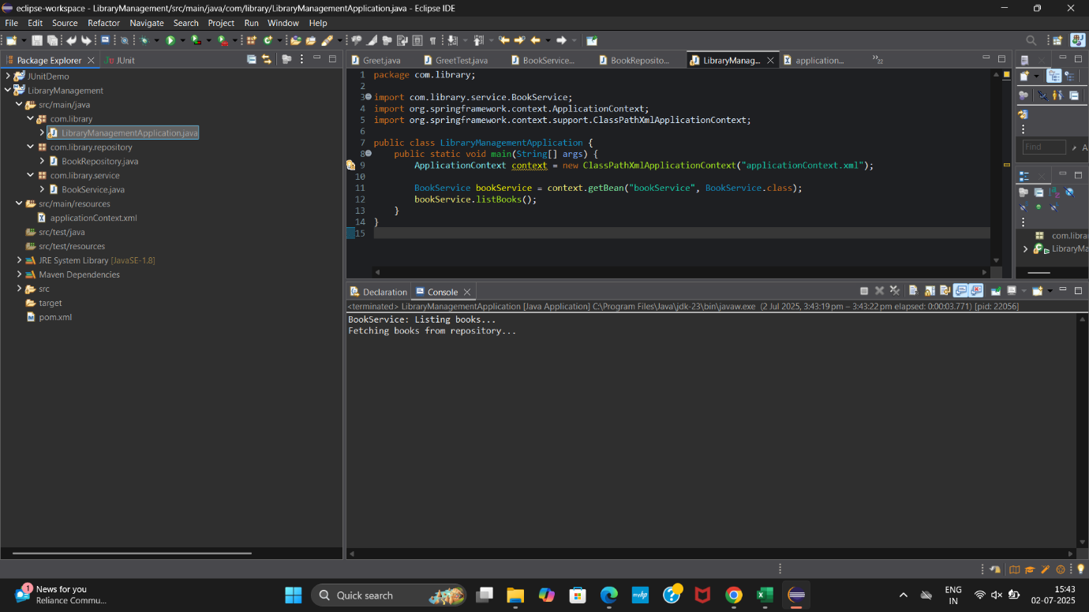

**Exercise 3: Implementing Logging with Spring AOP**

**Pom.xml**

<!-- Spring AOP -->

<dependency>

<groupId>org.springframework</groupId>

<artifactId>spring-aop</artifactId>

<version>5.3.32</version>

</dependency>

<!-- AspectJ Weaver (required for runtime weaving) -->

<dependency>

<groupId>org.aspectj</groupId>

<artifactId>aspectjweaver</artifactId>

<version>1.9.21</version>

</dependency>

**LoggingAspect.java**

package com.library.aspect;

import org.aspectj.lang.ProceedingJoinPoint;

import org.aspectj.lang.annotation.Around;

import org.aspectj.lang.annotation.Aspect;

@Aspect

public class LoggingAspect {

@Around("execution(* com.library.service.*.*(..))")

public Object logExecutionTime(ProceedingJoinPoint joinPoint) throws Throwable {

long startTime = System.currentTimeMillis();

Object result = joinPoint.proceed(); // method execution

long endTime = System.currentTimeMillis();

System.out.println(joinPoint.getSignature() + " executed in " + (endTime - startTime) + " ms");

return result;

}

}

**applicationContext.xml**

<beans xmlns="http://www.springframework.org/schema/beans"

xmlns:xsi="http://www.w3.org/2001/XMLSchema-instance"

xmlns:aop="http://www.springframework.org/schema/aop"

xsi:schemaLocation="

http://www.springframework.org/schema/beans

https://www.springframework.org/schema/beans/spring-beans.xsd

http://www.springframework.org/schema/aop

https://www.springframework.org/schema/aop/spring-aop.xsd">

<!-- Enable auto-proxying for aspects -->

<aop:aspectj-autoproxy />

<!-- Register your Aspect -->

<bean id="loggingAspect" class="com.library.aspect.LoggingAspect"/>

<!-- BookRepository and BookService beans -->

<bean id="bookRepository" class="com.library.repository.BookRepository"/>

<bean id="bookService" class="com.library.service.BookService">

<property name="bookRepository" ref="bookRepository"/>

</bean>

</beans>

**LibraryManagementApplication.java**

package com.library;

import org.springframework.context.ApplicationContext;

import org.springframework.context.support.ClassPathXmlApplicationContext;

import com.library.service.BookService;

public class LibraryManagementApplication {

public static void main(String[] args) {

ApplicationContext context = new ClassPathXmlApplicationContext("applicationContext.xml");

BookService = (BookService) context.getBean("bookService");

bookService.listBooks(); // <-- Method being logged by AOP

}

}

**OUTPUT**

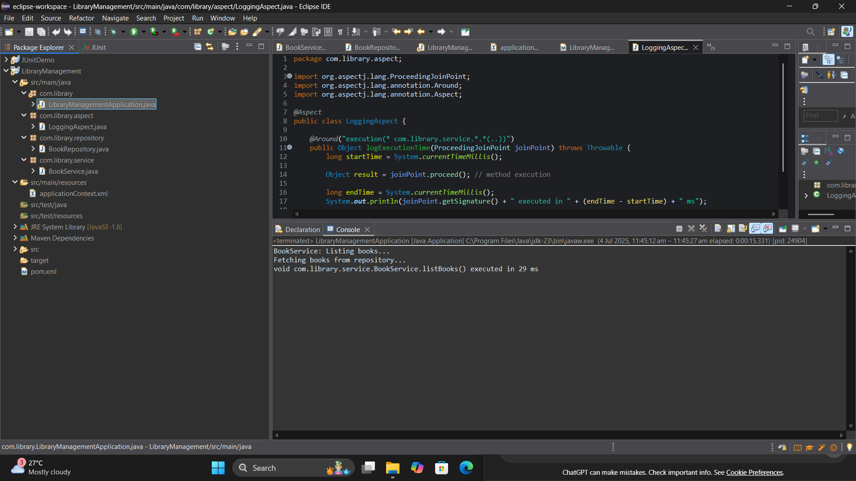

**Exercise 4: Creating and Configuring a Maven Project**

**Pom.xml**

<project xmlns="http://maven.apache.org/POM/4.0.0"

xmlns:xsi="http://www.w3.org/2001/XMLSchema-instance"

xsi:schemaLocation="http://maven.apache.org/POM/4.0.0

https://maven.apache.org/xsd/maven-4.0.0.xsd">

<modelVersion>4.0.0</modelVersion>

<groupId>com.library</groupId>

<artifactId>LibraryManagement</artifactId>

<version>1.0-SNAPSHOT</version>

<dependencies>

<!-- Spring Context (Core + Beans) -->

<dependency>

<groupId>org.springframework</groupId>

<artifactId>spring-context</artifactId>

<version>5.3.32</version>

</dependency>

<!-- Spring AOP -->

<dependency>

<groupId>org.springframework</groupId>

<artifactId>spring-aop</artifactId>

<version>5.3.32</version>

</dependency>

<!-- AspectJ Weaver (required for Spring AOP) -->

<dependency>

<groupId>org.aspectj</groupId>

<artifactId>aspectjweaver</artifactId>

<version>1.9.21</version>

</dependency>

<!-- Optional: Spring WebMVC (if planning to make it a web app) -->

<dependency>

<groupId>org.springframework</groupId>

<artifactId>spring-webmvc</artifactId>

<version>5.3.32</version>

</dependency>

</dependencies>

<!-- Compiler plugin for Java 8 -->

<build>

<plugins>

<plugin>

<artifactId>maven-compiler-plugin</artifactId>

<version>3.11.0</version>

<configuration>

<source>1.8</source>

<target>1.8</target>

</configuration>

</plugin>

</plugins>

</build>

</project>

**Exercise 6: Configuring Beans with Annotations**

**BookService.java**

package com.library.service;

import com.library.repository.BookRepository;

import org.springframework.beans.factory.annotation.Autowired;

import org.springframework.stereotype.Service;

@Service

public class BookService {

private BookRepository;

// Autowire the dependency using setter injection

@Autowired

public void setBookRepository(BookRepository bookRepository) {

this.bookRepository = bookRepository;

}

public void listBooks() {

System.out.println("BookService: Listing books...");

bookRepository.fetchBooks();

}

}

**BookRepository.java**

package com.library.repository;

import org.springframework.stereotype.Repository;

@Repository

public class BookRepository {

public void fetchBooks() {

System.out.println("BookRepository: Fetching books from database...");

}

}

**applicationContext.xml**

<?xml version="1.0" encoding="UTF-8"?>

<beans xmlns="http://www.springframework.org/schema/beans"

xmlns:xsi="http://www.w3.org/2001/XMLSchema-instance"

xmlns:context="http://www.springframework.org/schema/context"

xsi:schemaLocation="

http://www.springframework.org/schema/beans

https://www.springframework.org/schema/beans/spring-beans.xsd

http://www.springframework.org/schema/context

https://www.springframework.org/schema/context/spring-context.xsd">

<!-- Enable annotation-based configuration -->

<context:component-scan base-package="com.library" />

</beans>

**OUTPUT**

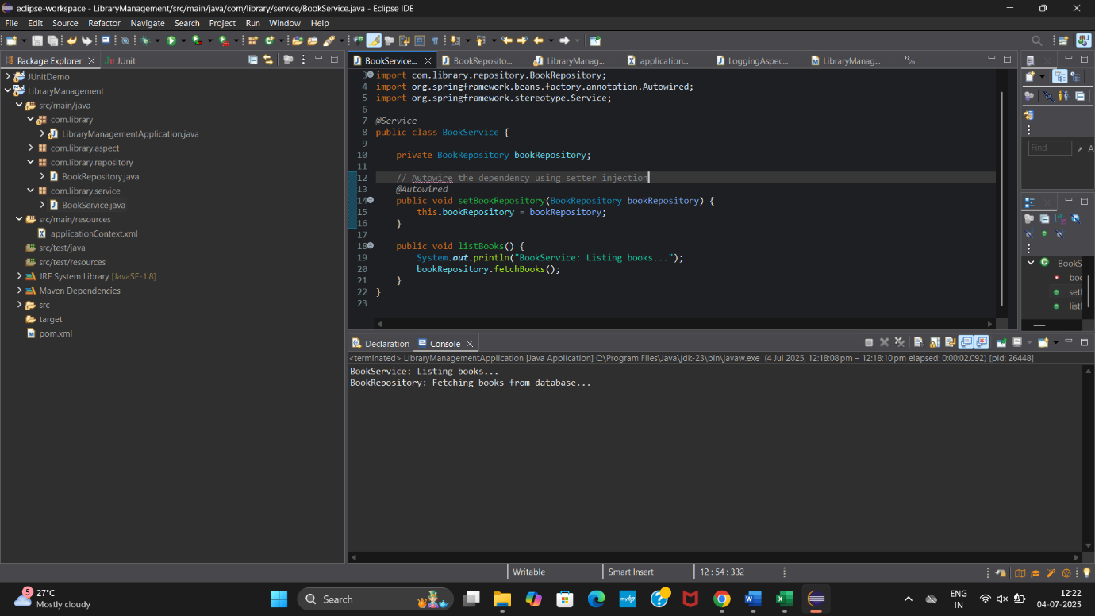

**Exercise 7: Implementing Constructor and Setter Injection**

**BookService.java**

package com.library.service;

import com.library.repository.BookRepository;

public class BookService {

private BookRepository;

// Constructor injection

public BookService(BookRepository bookRepository) {

this.bookRepository = bookRepository;

System.out.println("BookService: Constructor Injection used");

}

// Setter injection (optional)

public void setBookRepository(BookRepository bookRepository) {

this.bookRepository = bookRepository;

System.out.println("BookService: Setter Injection used");

}

public void listBooks() {

System.out.println("BookService: Listing books...");

bookRepository.fetchBooks();

}

}

**applicationContext.xml**

<?xml version="1.0" encoding="UTF-8"?>

<beans xmlns="http://www.springframework.org/schema/beans"

xmlns:xsi="http://www.w3.org/2001/XMLSchema-instance"

xsi:schemaLocation="

http://www.springframework.org/schema/beans

https://www.springframework.org/schema/beans/spring-beans.xsd">

<!-- BookRepository bean -->

<bean id="bookRepository" class="com.library.repository.BookRepository" />

<!-- BookService bean with constructor injection -->

<bean id="bookService" class="com.library.service.BookService">

<constructor-arg ref="bookRepository"/>

<!-- Optional: You can still keep setter injection too -->

<!-- <property name="bookRepository" ref="bookRepository"/> -->

</bean>

</beans>

**OUTPUT**

